1. Create a Stop watch using React.

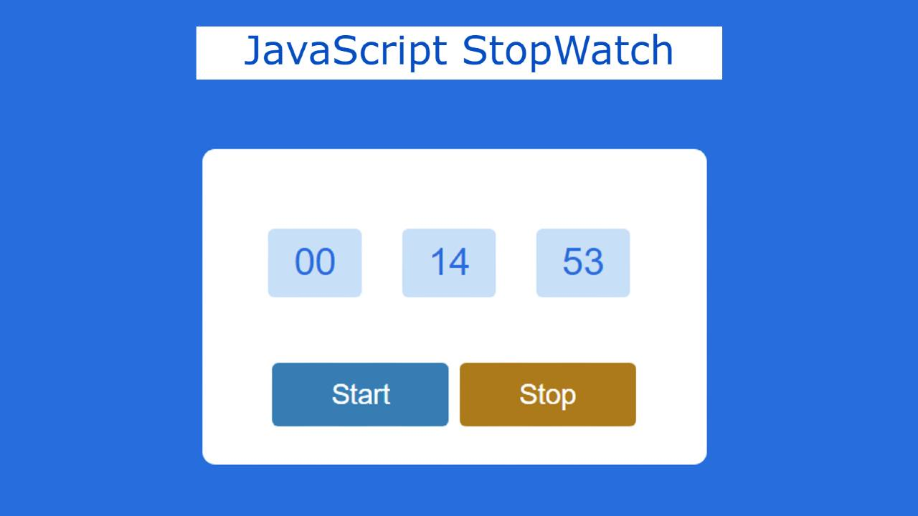

1. Create a component named employees that will take an array of employees from its parent and store it in state. Then create another component named employee that will render employee data as card.(Use Material UI here). Create an array of employee that contains name{firstName:””,lastName:””},profileImg, aboutMe .



1. Here create an employees component that will rendered all the employee as accordion menu like the below.

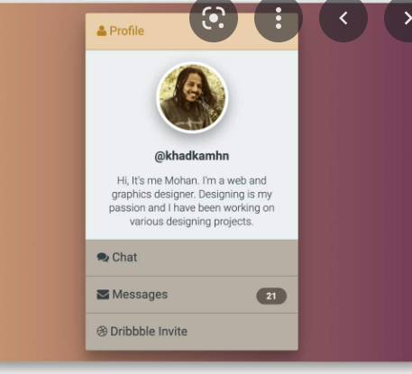

Here the Employee Array will contain name,profileImage,aboutMe text. Employee Name displays as the menu. When you click on one name the accordion menu will display the profile image and the about me text. Use Material UI accordian Menu.

1. Create a Table Component that will display all the employees data with two buttons at the end of each row. When you click on View button it will display the employee details in a div that is next to the table. When you click on delete button, the corresponding row will be deleted from the table.

